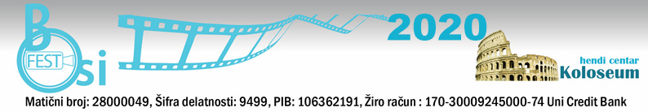
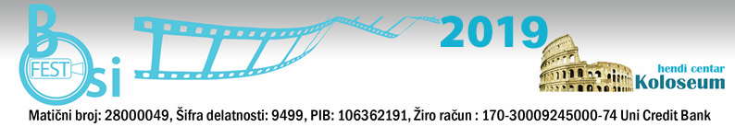
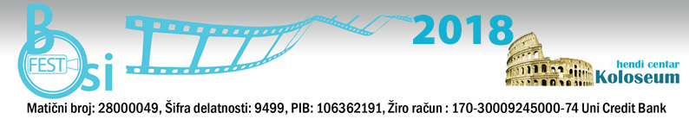

BOSIFEST 2020 – The Eleventh Belgrade International Film Festival for and by People with Disabilities
"BOSIFEST 2020"
From 19th to 21th October 2020
Venue: Yugoslav Cinematheque, Uzun Mirkova 1, Belgrade, Serbia
Submissions for the Eleventh Belgrade International Film Festival for and by people with Disabilities – BOSIFEST 2020 are open from January 24th 2020. until April 24th 2020.

What is BOSIFEST?

BOSIFEST is the International Film Festival for and by persons with disabilities, the only one of this kind in the Southeast Europe, which will be organized this year for the eleventh time in Serbia by the HendiCenter Koloseum. As in past ten years, this year on the big screen a great number of films will be shown both in competitive and non-competitive part. So far visitors of the BOSIFEST had an opportunity to watch 400 films that had life of the people with disabilities as their subject or were created by the disabled authors.

In addition to film screenings, BOSIFEST offers additional programs in the form of workshops, panel discussions and roundtables.

Why is BOSIFEST important?

The purpose of establishing BOSIFEST was to indicate the creative work and opportunities of the participants on the public cultural scene, and to spread the message that the people with disabilities should have the same rights and obligations as other citizens. Moreover, the festival provides a strong incentive for the adoption of measures for equal participation and integration of the people with disabilities into society.

Essential indicator that there is a need for this festival in Serbia is a great interest of authors and artists to participate in the BOSIFEST program. This festival joined the network of festivals in the whole world, which for many years engaged only in films about the people with disabilities, as well as the films written by the people with disabilities. The network provides the window of opportunity for the authors of the festivals to be seen on the world market, but also the ability to introduce new, innovative films dealing with themes relating to the lives of people with disabilities.

Films presented at the BOSIFEST attract great deal of public attention. Furthermore, every year, this film event contributes to informing the public about the rights, the status and needs of the people with disabilities, improves communication, contribute to the acceptance of diversity, and it is breaking down prejudices about persons with disabilities, and at the same

time, program of the BOSIFEST has stimulating effect on the creation of new film and artistic accomplishments.

Through a program BOSIFEST offers possible solutions for the further development of democratic society and environment that will be accessible and free of obstacles and barriers for everybody.

The festival promotes the City of Belgrade and Serbia through the richness of diversity and is committed to encourage our cultural and professional public to learn about the accomplishments of artists with disabilities from around the world, as well as to create conditions for exchange of views and experiences of film artists.

Darko Ivic, BOSIFEST Director
Hendi Center Koloseum, organizer of the BOSIFEST

For more information: http://bosifest.rs

