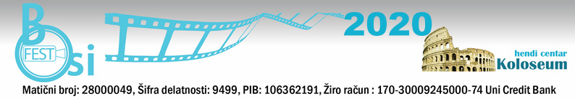
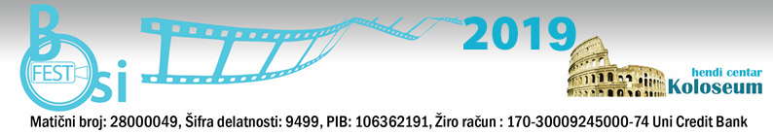

WE HEREBY INVITE YOU TO SUBMIT YOUR WORKS FOR PARTICIPATION
BOSIFEST 2020 – The Eleventh Belgrade International Film Festival for and by People with Disabilities
"BOSIFEST 2020"
From 19th to 21^{1h} October 2020
Venue: Yugoslav Cinematheque, Uzun Mirkova 1, Belgrade, Serbia

HENDI CENTRE KOLOSEUM ANNOUNCES
Submissions for BELGRADE INTERNATIONAL FILM FESTIVAL FOR AND BY PEOPLE WITH DISABILITIES – BOSIFEST 2020 are now open.
the topic is work and life of the people with disabilities.
Submissions are open from january 24th 2020, until April 24th, 2020.
The official selection results will be announced on jun 3th, 2020.
BOSIFEST 2020 will be held from 19th to 21th October 2020.

The festival is competitive; the entire program consists of both competitive and non-competitive parts. Films that are not chosen for the competition part of the program, and meet the requirements of the competition, will be in the non-competitive part of the program.

AWARDS:
-Best Film GRAND PRIX 2020 BOSIFEST
-For best director
- For the best-case scenario

The festival is organized by Hendi Center Koloseum, Panciceva Street 14, Belgrade, Serbia.
The festival was supported by Yugoslav Cinematheque.

The application rules and requirements:
1. Genre: documentary films dealing with the issues concerning people with disabilities
2. Duration: up to 100 minutes
3. The film must be in English or with English/Serbian Subtitles
4. The film must be produced in the last 5 years
5. The film must be sent no later than April 24th, 2020.
6. All videos must be in DVD format
7. BOSIFEST can use parts of the received materials for advertising purposes (up to minutes)
8. The Selection Commission has to receive at least two copies of the film (DVD format), and the Festival will retain all copies.

It is necessary to submit the following supporting material:
- Plot synopsis or textual expose lengths between 100 and 200 words
- Dialogue-list (if any)
-Two film captions or photographs of the filming process
- The author’s biography and photo
-Year and place of birth of the film author/authoress, occupation, place of residence and contact information (phone and e-mail)

In addition to the film submissions, submissions for the additional activities and workshops proposals are open. Workshops will be held during the BOSIFEST 2020 at the festival venue.

Films and supporting materials should be marked “BOSIFEST 2020 Submissions" and sent to:
Hendi Centar Koloseum,
Pančićeva 14
11000 Belgrade
Serbia

Questions about the submissions should be sent to: film@bosifest.rs
hc.koloseum@gmail.com
Phone / fax: +381 11 263 78 20 (10-14h)
For more information:http://bosifest.rs

Festival Director
Darko Ivic

